One day Regional Work Shop
On
Sustainable and Disaster Resilient Urban Development

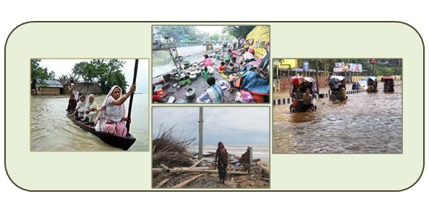
Tuesday, September 09, 2014, Ahmedabad

Hyatt Regency, Vastrapur

Ahmedabad, Gujarat, India

Organised By

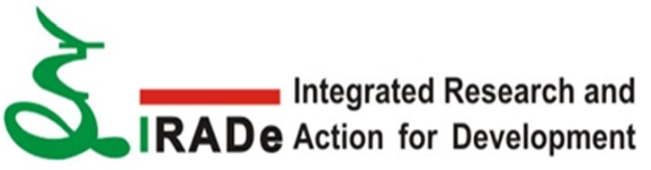
Integrated Research and Action for Development (IRADe), New Delhi

Supported by
Ministry of Urban Development, New Delhi, Government of India
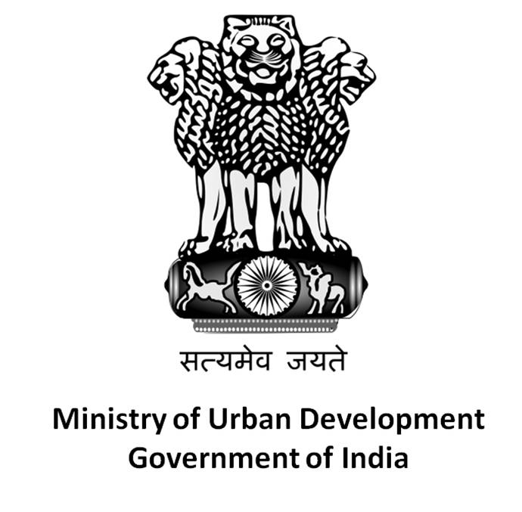

SUSTAINABLE AND DISASTER RESILIENT URBAN DEVELOPMENT

Background

Urbanization trend is expected to accelerate in coming decades in India. It is projected that the number of cities with a population of more than 1 million will reach from 53 in 2011to 75 by 2021. India is particularly exposed to earthquakes (and associated tsunamis), floods, droughts, cyclones, and landslides. About 60 percent of the landmass is prone to earthquakes of varying intensities, over 8 percent is prone to floods, 75 percent of coastline is prone to cyclones, and 68 percent of the area is susceptible to drought. Direct losses in India average 2 percent of India’s GDP, and have been as high as 12 percent of central government revenues (GFDDAR, 2012). It could also become a strategic economic and political concern as it starts to erode India's economic performance and affect the lives and livelihoods of millions of people. That is why it is highly important to combine disaster risk reduction (DRR) in urban planning for making cities disaster resilient and sustainable.

About the project

IRADe is sponsored under Capacity building program of Ministry of Urban Development, Government of India to augment City Development Plans (CDPs) of 10 cities in five regions of country which are as follows:

- East India- Shillong, Bhubaneswar, Guwahati
- West India- Pune, Ahmedabad, Bhopal
- South India- Vishakhapatnam, Hyderabad
- North India- Dehradun, Srinagar

Key outputs of the project are as follows –

- Development of 10 city case studies to augment City Development Plans.
- City specific capacity building and knowledge dissemination
- Regional workshop for finalizing strategies for disaster resilient cities,

Purpose of the workshop

IRADe has been involved in developing city case studies through city visits, meeting with relevant city stakeholders and reviewing existing City Master plan, City Development Plan, City Disaster management Plan, Service Level Benchmarks (SLB) etc.

The main purpose of the West India Regional workshop is to report draft finding of IRADe work on Pune, Ahmedabad and Bhopal cities to finalise strategies for disaster resilient cities.

It also aims to build the capacity of city stakeholders (policy makers, urban planners, city administrators, experts, academicians and aid agencies from different regions of India to strengthen the disaster resilient mechanism and issues regarding disaster related climate vulnerability of the cities and help them to deal with the related stress and formulate adaptation strategies

PROGRAMME SCHEDULE

One Day Regional Workshop on
“Sustainable and Disaster Resilient Urban Development”
On
Tuesday September 09, 2014

At

Hyatt Ahmedabad
Plot 216, Town Plan Scheme 1, Near Vastrapur Lake, Vastrapur
Ahmedabad, India

09.15 – 10.00 | Registration
10.00-11.15 | Inaugural Session  Dr. Jyoti K Parikh, Executive Director, IRADe Welcome Address  Mr. G S Aloria, Additional Chief Secretary, Inaugural Address  Urban Development and Urban Housing Department  Govt. of Gujarat  Mr. Jay B Kshirsagar, Chief Planner, TCPO Special Address  Ministry of Urban Development, Govt. of India  G. Padmanabhan,Emergency Analyst & Key note Address  Officer in charge DM Unit, UNDP  Vote of Thanks  Mr Rohit Magotra, Assistant Director, IRADe
11.15 - 11:30 | Tea Break
11.30 – 13.00 | Sustainable and Disaster Resilient urban development and Disaster Risk Reduction  Co-Chair: Mr. Rajesh Kumar, Senior Architect, CPWD(Gandhinagar)  IRADe : Technical Presentations – City case Studies  Discussants:  Mr K K Bishnoi , Chief Fire Officer, Jamnagar Municipal Corporation  Ms .Meghna Malhotra, Deputy Director, UMC, Ahmedabad.  Mr. Rajiv Mishra, Research Fellow, MP State Disaster Management Authority  Ms Rakhibhen Trivedi, Additional City Engineer, AMC
13.00 – 14.00 | Lunch Break
14.00 – 15.30 | Capacity Building for disaster resilience , innovation and local funding  Chair: Mr. Jay B Kshirsagar, Chief Planner, TCPO  Co-chair: Dr. Janki Andharia, Professor , Jamsetji Tata Centre for Disaster Management, TISS  Panelists:  Mr. A.N Krishnamurthy, Ex Director HSMI  Mr G K Bhat, Managing Director, TARU Leading Edge Pvt Ltd  Mr. Ashwini Kumar, Associate Professor, CEPT  Ms Jaladi Vavaliya, Senior Researcher, PAS Project
15.30- 16.00 | Tea Break
16.00 – 17.00 | Valedictory Session  Dr. Jyoti K Parikh, Executive Director, IRADe

About IRADe
IRADe is a fully autonomous advanced research institute, which aims to conduct research and policy analysis and connect various stakeholders including government, non-governmental organizations (NGOs), corporations, and academic and financial institutions. Its research covers many areas such as energy and power systems, urban development, climate change and
environment, poverty alleviation and gender, food security and agriculture, as well as the policies that affect these areas.

For more information and registration pl contact:

Mr.Rohit Magotra:
Email: rmagotra@irade.org
Phone: 09871613840, +91 11 2667 6181, +91 11 2667 6180

Ms Geeta Sandal:
Email: geetas@irade.org
Phone: 09310928273

